Towards Unifying Sequence Modeling and Feature Interaction
for Large-scale Recommendation
Midterm Report Draft + Exact Model Architecture
Course: COM SCI 247 | Team Members: Ibrahim Bitar, Dang Le | Date: 5/1/2026
Working thesis: We model user/item/context features and multi-domain behavior sequences as a unified token sequence, then use a homogeneous Transformer-style backbone with field, domain, position, and feature-type embeddings to jointly learn sequential dynamics and cross-field feature interactions for CVR prediction.

1. Proposed Model Architecture: UFI-Former
We propose UFI-Former, a unified feature-interaction Transformer for conversion-rate prediction under ROC-AUC evaluation and an inference latency budget. The model is designed to satisfy the competition theme by processing static multi-field features and behavioral sequences inside one shared, stackable backbone rather than separate feature-crossing and sequence modules.

1.1 Input Tokenization
- ID inputs: user_id and item_id are treated as sparse identifier tokens. label_type is the target label and is never used as an input. label_time/timestamp are excluded from the initial model to avoid leakage unless converted into safe time-derived features.
- Scalar categorical fields: each scalar user_int_feats_* and item_int_feats_* value becomes one token represented by value embedding + field embedding + feature-type embedding.
- Multi-value categorical fields: each list<int64> value becomes multiple tokens sharing a field embedding. Lists are padded/truncated to a maximum length.
- Dense aligned fields: each user_dense_feats_* value is projected to the embedding dimension and added to its aligned sparse token.
- Domain sequence fields: each domain_a/b/c/d_seq_* token receives value, field, domain, position, and type embeddings.
Token source | Example columns | Representation
Static user sparse | user_int_feats_1, 3, 4, ... | Embedding(value) + field + type
Static item sparse | item_int_feats_5-13, 16, 81, 83-85 | Embedding(value) + field + type
Multi-value sparse | user_int_feats_62-66, 89-91; item_int_feats_11 | One token per element; truncate/pad or pool
Dense aligned stats | user_dense_feats_62-66, 89-91 | Linear projection added to aligned sparse token
Domain sequences | domain_a/b/c/d_seq_* | Embedding(value) + domain + position + field + type

1.2 Backbone
- Input sequence: [CLS], static user tokens, static item tokens, dense-aligned tokens, and domain sequence tokens.
- Encoder: shared Transformer encoder blocks with multi-head self-attention, feed-forward layers, residual connections, and LayerNorm.
- Pooling: [CLS] representation plus optional attention pooling over static and sequence tokens.
- Prediction head: compact MLP that outputs a raw logit for CVR prediction.
- Training objective: BCEWithLogitsLoss; validation metric: ROC-AUC when the validation labels contain both positive and negative classes.

Layer | Operation | Purpose
Token embedding | value + field + type + domain + position embeddings | Unifies static and sequential inputs
Transformer block x N | Self-attention + FFN + residual + LayerNorm | Learns sequence patterns and feature interactions jointly
Pooling | CLS + optional attention pooling | Builds a stable global representation
MLP head | pooled representation -> hidden -> raw logit | Predicts conversion probability

1.3 Practical Hyperparameter Plan
Version | Goal | d_model | Blocks | Max sequence tokens | Expected use
V0: sanity baseline | Fast debugging | 64 | 1 | 64 | Verify pipeline and stable loss
V1: midterm model | Balanced AUC/latency | 128 | 2 | 128 | Primary midterm architecture
V2: stronger model | Improve leaderboard | 192 | 4 | 192 | If GPU memory allows
V3: scaling study | Innovation angle | 64/128/192/256 | 1/2/4/6 | 64/128/256 | Report AUC vs parameters and latency

2. Midterm Report

2.1 Methodology
Our approach is to build a unified recommender architecture for CVR prediction that jointly models non-sequential multi-field features and user behavior sequences. We start with a simple PyTorch MLP baseline on the Hugging Face sample dataset, then use the results to debug the data pipeline before scaling to UFI-Former. The central design decision is to represent every categorical value, dense aligned signal, and sequence event as a token in the same embedding space. This lets the model learn feature interactions and sequential dependencies using the same self-attention blocks.
The current baseline intentionally uses a small subset of features and the TAAC2026/data_sample_1000 dataset for pipeline validation. Once the pipeline is stable, the model will be extended to include all scalar, multi-value, dense-aligned, and sequence features.

2.2 Completed Work
- Reviewed the competition objective, dataset schema, evaluation metric, timeline, and midterm report requirements.
- Loaded the sample dataset using Hugging Face Datasets: load_dataset("TAAC2026/data_sample_1000").
- Built and ran a PyTorch baseline training notebook in Google Colab.
- Identified and fixed the loss-function issue by replacing BCELoss/sigmoid usage with BCEWithLogitsLoss and raw logits.
- Saved a fixed baseline checkpoint and training history for reproducibility.
- Designed the UFI-Former architecture for the next phase of implementation.

2.3 Preliminary Results
After fixing the loss-function issue, training became numerically stable: both training loss and validation loss decreased monotonically over 15 epochs. However, validation AUC is currently reported as NaN because the validation split/sample likely contains only one label class, so ROC-AUC is mathematically undefined. This is a data-splitting/evaluation issue, not the same instability observed in the first run.

Epoch | Train Loss | Validation Loss | Validation AUC
1 | 0.7179 | 0.7301 | NaN: validation labels need both classes
3 | 0.6438 | 0.6843 | NaN: validation labels need both classes
5 | 0.5878 | 0.6357 | NaN: validation labels need both classes
10 | 0.4631 | 0.5137 | NaN: validation labels need both classes
15 | 0.3557 | 0.4228 | NaN: validation labels need both classes
The best validation loss in the current run occurs at epoch 15 with validation loss = 0.4228. The official leaderboard screenshot is included for context; top visible scores are approximately 0.828 AUC, which represents a much stronger benchmark than the 1K-sample debugging baseline.
Figure 1. Current competition leaderboard reference screenshot.
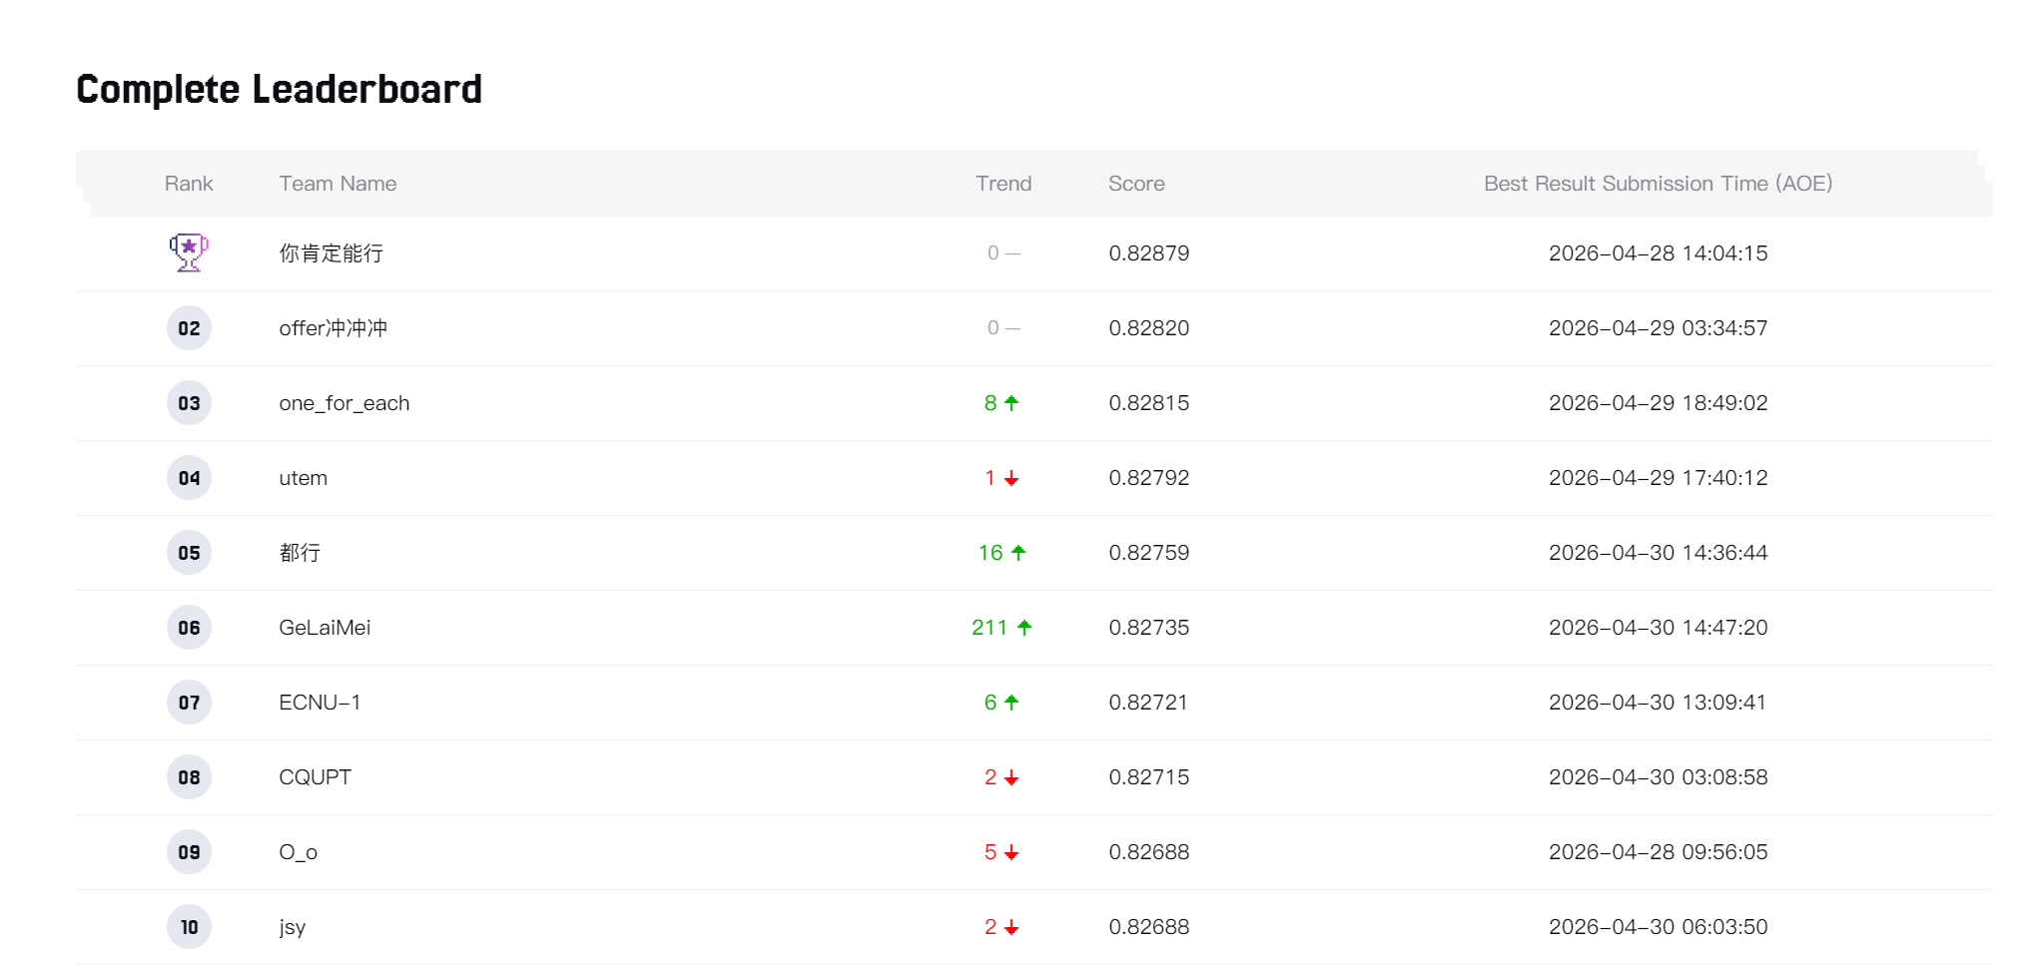

2.4 Debugging Findings
- Initial training produced negative BCE loss and AUC collapse to 0.5, indicating incorrect loss usage or numerical instability.
- The fixed run uses raw logits with BCEWithLogitsLoss, which keeps losses positive and decreasing.
- The remaining issue is NaN ROC-AUC, which occurs when the validation split has only one class. We need a stratified validation split or a larger sample with both positive and negative labels.
- For the report, validation loss is currently the reliable sanity metric; ROC-AUC should be reported after fixing the split.

2.5 Findings So Far
- The Hugging Face sample is useful for debugging the pipeline but too small for reliable leaderboard-style AUC measurement.
- A stable loss curve confirms that the corrected baseline training loop is functioning.
- ROC-AUC must be computed only when the validation set contains at least one positive and one negative sample.
- The leaderboard shows that competitive systems are near 0.828 AUC, so our current baseline should be treated as infrastructure validation rather than a competitive model.

2.6 Challenges and Plans
Challenge | Why it matters | Planned solution
Validation AUC is NaN | ROC-AUC is undefined if validation labels have one class | Use stratified split and verify label distribution before training
Large sparse ID space | Embedding tables can overfit or become memory-heavy | Use hashing, OOV buckets, frequency cutoffs, and embedding dropout
Long behavior sequences | Attention cost grows with sequence length | Truncate to recent K events and test K=64/128/256
Latency constraint | Slow models may be invalid even with high AUC | Benchmark inference time; keep V1 compact
Unclear best tokenization | Fields have different semantics | Ablate field/domain/type embeddings and dense projections
Scaling to full dataset | 1K sample is not representative | Move from sample to full academic-track dataset after pipeline validation

2.7 Next Steps
- Print and record train/validation label counts to confirm both classes exist.
- Re-run the fixed notebook with a stratified split or a larger dataset sample.
- Report validation ROC-AUC after the split is corrected.
- Implement a stronger feature-interaction baseline such as DeepFM.
- Extend the baseline tokenization to include sequence fields and dense-aligned features.
- Train UFI-Former V1 and submit predictions to obtain an official leaderboard screenshot for the final report.
- Run scaling experiments over embedding dimension, layer count, and sequence length.

2.8 Contribution Statement
The contribution statement below should be finalized with the team’s exact division of labor.
Member | Responsibilities
Ibrahim Bitar | Dataset loading in Colab, baseline notebook execution, training-output collection, leaderboard screenshot, report coordination.
Dang Le | Feature schema review, model architecture review/implementation support, experiment tracking, report editing.

3. PyTorch Implementation Workflow
The project should be developed in Google Colab, Kaggle, or a university GPU environment. A local computer is acceptable for reading the schema and debugging small samples, but full training on 1-2 million samples with sequence features is better suited to GPU-backed environments.
Option | When to use | Pros | Cons
Local PC CPU | Small subset, debugging | Simple setup | Slow training and memory limits
Local PC GPU | NVIDIA GPU available | Convenient and faster | May still struggle with large embeddings
Google Colab/Kaggle | Student-friendly experiments | Easy notebooks and GPU access | Session limits
University/server GPU | Serious training/submissions | Stable and scalable | Requires access/setup

4. Starter Implementation Plan
- dataset.py: reads Hugging Face/parquet/csv data and builds token IDs, masks, dense values, and labels.
- model.py: implements UnifiedEmbedding, TransformerEncoder, pooling, and MLP head.
- train.py: trains with BCEWithLogitsLoss, computes validation ROC-AUC when valid, saves best checkpoint.
- submit.py: loads checkpoint, generates test probabilities, and writes the required submission file.
- experiments.csv: records model size, sequence length, validation loss/AUC, leaderboard AUC, and latency.

5. Suggested Architecture Figure
Figure description: static user/item fields, dense aligned features, and four-domain behavior sequences are converted into one unified token sequence. Field/type/domain/position embeddings are added, the tokens pass through shared Transformer blocks, and the pooled representation feeds an MLP head for CVR prediction.

Appendix: Architecture Pseudocode
tokens = [CLS]
tokens += embed_static_user_item_features(...)
tokens += embed_multivalue_features(..., dense_aligned_values)
tokens += embed_domain_sequences(domain_a, domain_b, domain_c, domain_d)
x = token_embedding(tokens) + field + type + domain + position embeddings
h = TransformerEncoder(x, attention_mask)
z = concat(h[CLS], attention_pool(h[sequence_tokens]), mean_pool(h[static_tokens]))
logit = MLP(z)
loss = BCEWithLogitsLoss(logit, label)
metric = ROC_AUC(sigmoid(logit), label) # only when both classes exist

